Impact vs. Non-impact
There are several major printer technologies available. These technologies can be broken down into two main categories with several types in each:
- Impact - These printers have a mechanism that touches the paper in order to create an image. There are two main impact technologies:
  - Dot matrix printers use a series of small pins to strike a ribbon coated with ink, causing the ink to transfer to the paper at the point of impact.
  - Character printers are basically computerized typewriters. They have a ball or series of bars with actual characters (letters and numbers) embossed on the surface. The appropriate character is struck against the ink ribbon, transferring the character's image to the paper. Character printers are fast and sharp for basic text, but very limited for other use.
- Non-impact - These printers do not touch the paper when creating an image. Inkjet printers are part of this group, which includes:
  - Inkjet printers, which are described in this article, use a series of nozzles to spray drops of ink directly on the paper.
  - Laser printers, covered in-depth in How Laser Printers Work, use dry ink (toner), static electricity, and heat to place and bond the ink onto the paper.
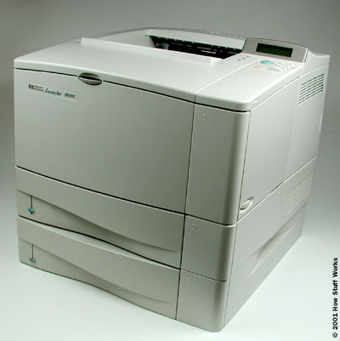
A Hewlett Packard LaserJet 4050T
  - Solid ink printers contain sticks of wax-like ink that are melted and applied to the paper. The ink then hardens in place.
  - Dye-sublimation printers have a long roll of transparent film that resembles sheets of red-, blue-, yellow- and gray-colored cellophane stuck together end to end. Embedded in this film are solid dyes corresponding to the four basic colors used in printing: cyan, magenta, yellow and black (CMYK). The print head uses a heating element that varies in temperature, depending on the amount of a particular color that needs to be applied. The dyes vaporize and permeate the glossy surface of the paper before they return to solid form. The printer does a complete pass over the paper for each of the basic colors, gradually building the image.
  - Thermal wax printers are something of a hybrid of dye-sublimation and solid ink technologies. They use a ribbon with alternating CMYK color bands. The ribbon passes in front of a print head that has a series of tiny heated pins. The pins cause the wax to melt and adhere to the paper, where it hardens in place.
  - Thermal autochrome printers have the color in the paper instead of in the printer. There are three layers (cyan, magenta and yellow) in the paper, and each layer is activated by the application of a specific amount of heat. The print head has a heating element that can vary in temperature. The print head passes over the paper three times, providing the appropriate temperature for each color layer as needed.
Out of all of these incredible technologies, inkjet printers are by far the most popular. In fact, the only technology that comes close today is laser printers.
So, let's take a closer look at what's inside an inkjet printer.

inside an Inkjet Printer
Parts of a typical inkjet printer include:
- Print head assembly
  - Print head - The core of an inkjet printer, the print head contains a series of nozzles that are used to spray drops of ink.
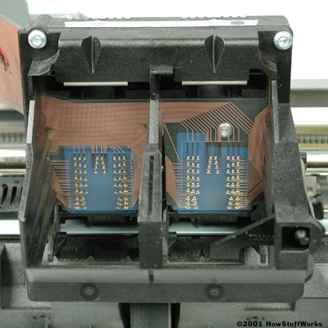
The print head assembly
  - Ink cartridges - Depending on the manufacturer and model of the printer, ink cartridges come in various combinations, such as separate black and color cartridges, color and black in a single cartridge or even a cartridge for each ink color. The cartridges of some inkjet printers include the print head itself.
  - Print head stepper motor - A stepper motor moves the print head assembly (print head and ink cartridges) back and forth across the paper. Some printers have another stepper motor to park the print head assembly when the printer is not in use. Parking means that the print head assembly is restricted from accidentally moving, like a parking brake on a car.
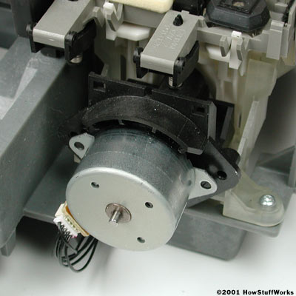
Stepper motors like this one control the movement of most parts of an inkjet printer.
  - Belt - A belt is used to attach the print head assembly to the stepper motor.
  - Stabilizer bar - The print head assembly uses a stabilizer bar to ensure that movement is precise and controlled.
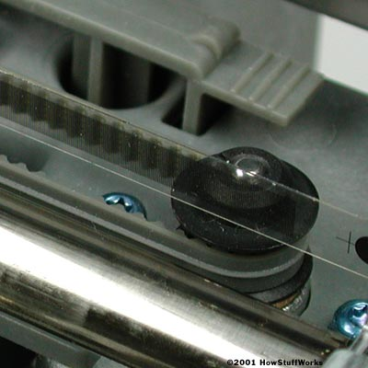
Here you can see the stabilizer bar and belt.
- Paper feed assembly
  - Paper tray/feeder - Most inkjet printers have a tray that you load the paper into. Some printers dispense with the standard tray for a feeder instead. The feeder typically snaps open at an angle on the back of the printer, allowing you to place paper in it. Feeders generally do not hold as much paper as a traditional paper tray.
  - Rollers - A set of rollers pull the paper in from the tray or feeder and advance the paper when the print head assembly is ready for another pass.
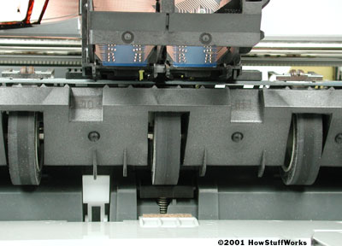
The rollers move the paper through the printer.
  - Paper feed stepper motor - This stepper motor powers the rollers to move the paper in the exact increment needed to ensure a continuous image is printed.
- Power supply - While earlier printers often had an external transformer, most printers sold today use a standard power supply that is incorporated into the printer itself.
- Control circuitry - A small but sophisticated amount of circuitry is built into the printer to control all the mechanical aspects of operation, as well as decode the information sent to the printer from the computer.
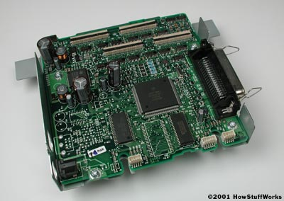
The mechanical operation of the printer is controlled by a small circuit board containing a microprocessor and memory.
- Interface port(s) - The parallel port is still used by many printers, but most newer printers use the USB port. A few printers connect using a serial port or small computer system interface (SCSI) port.
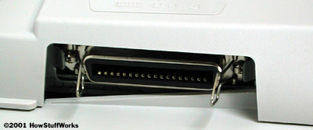
While USB taking over, many printers still use a parallel port.

Paper and Ink
Inkjet printers are fairly inexpensive. They cost less than a typical black-and-white laser printer, and much less than a color laser printer. In fact, quite a few of the manufacturers sell some of their printers at a loss. Quite often, you can find the printer on sale for less than you would pay for a set of the ink cartridges!
Why would they do this? Because they count on the supplies you purchase to provide their profit. This is very similar to the way the video game business works. The hardware is sold at or below cost. Once you buy a particular brand of hardware, then you must buy the other products that work with that hardware. In other words, you can't buy a printer from Manufacturer A and ink cartridges from Manufacturer B. They will not work together.
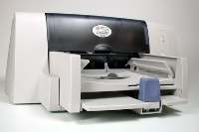
This printer sells for
less than $100.
Another way that they have reduced costs is by incorporating much of the actual print head into the cartridge itself. The manufacturers believe that since the print head is the part of the printer that is most likely to wear out, replacing it every time you replace the cartridge increases the life of the printer.
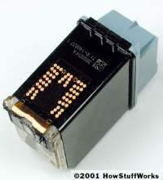
A typical color ink cartridge:
This cartridge has cyan, magenta and yellow inks in separate reservoirs.
The paper you use on an inkjet printer greatly determines the quality of the image. Standard copier paper works, but doesn't provide as crisp and bright an image as paper made for an inkjet printer. There are two main factors that affect image quality:
- Brightness
- Absorption
The brightness of a paper is normally determined by how rough the surface of the paper is. A course or rough paper will scatter light in several directions, whereas a smooth paper will reflect more of the light back in the same direction. This makes the paper appear brighter, which in turn makes any image on the paper appear brighter. You can see this yourself by comparing a photo in a newspaper with a photo in a magazine. The smooth paper of the magazine page reflects light back to your eye much better than the rough texture of the newspaper. Any paper that is listed as being bright is generally a smoother-than-normal paper.
The other key factor in image quality is absorption. When the ink is sprayed onto the paper, it should stay in a tight, symmetrical dot. The ink should not be absorbed too much into the paper. If that happens, the dot will begin to feather. This means that it will spread out in an irregular fashion to cover a slightly larger area than the printer expects it to. The result is an page that looks somewhat fuzzy, particularly at the edges of objects and text.

Imagine that the dot on the left is on coated paper and the dot on the right is on low-grade copier paper. Notice how irregular and larger the right dot is compared to the left one.
As stated, feathering is caused by the paper absorbing the ink. To combat this, high-quality inkjet paper is coated with a waxy film that keeps the ink on the surface of the paper. Coated paper normally yields a dramatically better print than other paper. The low absorption of coated paper is key to the high resolution capabilities of many of today's inkjet printers. For example, a typical Epson inkjet printer can print at a resolution of up to 720x720 dpi on standard paper. With coated paper, the resolution increases to 1440x720 dpi. The reason is that the printer can actually shift the paper slightly and add a second row of dots for every normal row, knowing that the image will not feather and cause the dots to blur together.
Inkjet printers are capable of printing on a variety of media. Commercial inkjet printers sometimes spray directly on an item like the label on a beer bottle. For consumer use, there are a number of specialty papers, ranging from adhesive-backed labels or stickers to business cards and brochures. You can even get iron-on transfers that allow you to create an image and put it on a T-shirt! One thing is for certain, inkjet printers definitely provide an easy and affordable way to unleash your creativity.
Refilling Cartridges
Because of the expense of inkjet cartridges, a huge business has grown around the idea of refilling them. For most people, refilling makes good sense, but there are a few things to be aware of:
- Make sure the refill kit is for your printer model. As you learned in the previous section, different printers use different technologies for putting the ink on the paper. If the wrong type of ink is used, it can degrade the output or possibly damage the printer. While some commercial inkjets use oil-based inks, virtually all desktop inkjets for home or office use have water-based ink. The exact ink composition varies greatly between manufacturers. For example, thermal bubble inkjets need ink that is stable at higher temperatures than piezoelectric printers.
- Most manufacturers require that you use only their approved ink. Refill kits normally will void your warranty.
- While you can refill cartridges, be very careful of the ones that have the print head built into the cartridge. You do not want to refill these more than two or three times, or the print head will begin to deteriorate and could damage your printer.

